Virtual Apps & Desktops displays?

When looking at the **Views - Citrix Virtual Apps and Desktops** page of Goliath Performance Monitor, on the **Published Apps & Desktops** and **Virtual Desktops** tabs of the display, there is a column labeled **Version**. The **Version** column is displaying what version of Citrix Receiver or Workspace app is installed on the end users client machine.

Figure 1 - Published Apps And Desktops tab

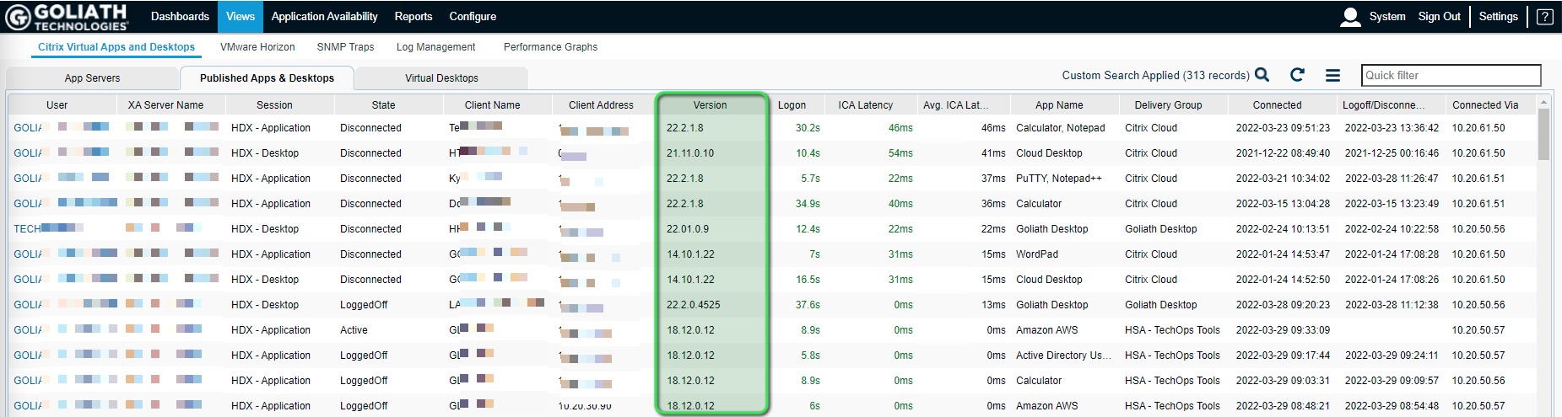

Figure 2 - Virtual Desktops tab

